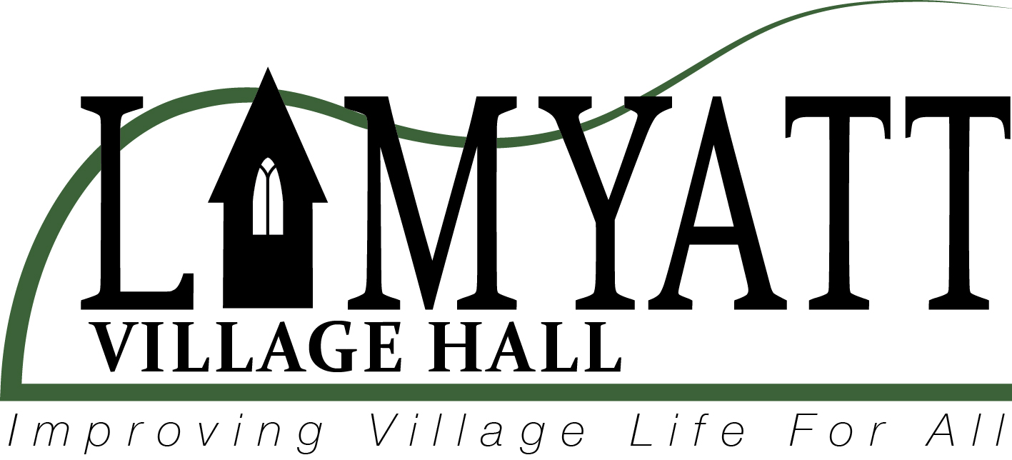

Lamyatt Village Hall Trust Report 2025

At present we have 11 Trustees
Kara Thomas – Chair
Emily Harris – Minute Secretary
Jonathan Orrell – Treasurer
Simone Ash – Resources
Martin Stansbie – Maintenance
Kelly Biss – Publicity & Website
Helen Rutter – Program
Caroline Duggan – Governance
Kellie Walters – Diary
Jonathan Bone – First Aid
Ann Skinner - Church

History
The Village Hall is a charitable trust formed in 1979 operating in the Old School Building. There were 12 Trustees from the village among them Freda Gibbons. A recent roll call carried out with her revealed she is the only one still with us, but long may that continue.

Moving forward to the 2010’s plans were put in place for an expanded hall, money was raised Shakespeare, Bullbeggar Cider, and some very significant grants from charitable funding organisations. It is generally accepted that the current hall is a wonderful building and perhaps the jewel of all village halls.

Activities
We are operating today providing ,shows, films and educational talks, coffee mornings, social evenings often accompanied by live music, as well as daytime activities bridge and Pilates. The hall is open to all for hire. We aim to cater for every taste. There is a Program sub-committee that can be contacted if you have a suggestion (rutterhelen1@gmail.com).

Support from Villagers
We do receive some great support. Big thanks:
Philip Stone and family for clearing the ditches around the Hall and hopefully prevent the flooding that occurred in the Hall last winter

Alan Candy for manufacturing and installing extra railings for the steps on the terrace

Nick and Romy Smallwood for running the National Film Theatre evenings and much more

Jonny Tapp in his continuing efforts to repair the Hall Shutters

Aksel Frostrup who provides excellent advice with building maintenance

Malcolm Cooper who constructed our bar trolley

Hilary Pascoe is now assisting as a safety officer to ensure weekly checks are done

Neil Mantell who continues to service the defibrillator

What we need:
More trustees. We have eleven now and two are due to leave. The optimum number is 12. So, three vacancies. If you have a feeling that you could do the job. Get in touch! (jonorrell51@gmail.com)

More voluntary help in running activities especially workdays cleaning and carrying out minor repairs and finishing with tea and cake.

Finance
Thanks to the fundraising in the past, we are well off with £30,000 invested and £5,000 in the bank account. We also benefitted from government grants to support the hall during covid.

This is great however over the past three years there has been a loss in trading of about £2000. This year is very much on the same course. We must find a way to pay our way.

One obvious way of turning this round is more hires. Please hire the hall. It is only £10 per hour. It will make a difference but at the moment this is not really happening. Any other good ideas Get in touch!

Because of the losses there is a reluctance to carry out some repairs and improvements.

We should have the means to not only break even but to make a profit to provide beyond the hall. For example, refurbishing the old bus stop or even the new bus stop. To give more support to the church that has a much harder job to raise money.

Please support the hall in whatever way you can. There is a role to play as being at the heart of the village and make life brighter for all

Jonathan Orrell
Treasurer
Lamyatt Village Hall
jonorrell51@gmail.com
07722415902

